Data Feed HRA/FSA/DCA Plan Employee Handout Instructions

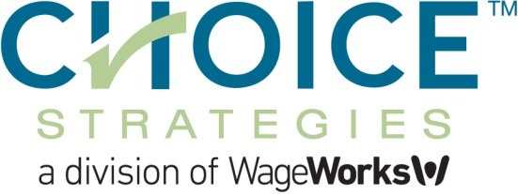

Getting Started: You can customize this employee handout template to help your employees understand which Choice Strategies benefit account(s) you are offering them, and how they can be used in conjunction with their health insurance plan.

As many employees may be new to consumer-driven health care, this handout can be a helpful tool to easily provide them with the essential information, links and resources needed to fully take advantage of their specific plan – all in one place.

Before distributing this handout to employees, please find and edit the following, and then delete this page:

- Replace Group Name with your group name
- Replace Carrier with your Health Insurance Carrier name
- Replace January 1, 2018 with your group’s effective date
- Replace 1/1/2018-12/31/2018 with your group’s plan year
- Replace $$$$ with your group’s HRA funding for Single, Two-Person and Family
- Review and edit HRA / Carrier deductible eligible expenses section
- Replace $2,650 with your group’s allowed FSA maximum
- If you are offering an FSA Carryover, remove the paragraph describing “Use it or Lose It”. If you are not offering an FSA Carryover, remove the paragraph describing the Carryover. You will also need to remove the highlighted instructions.
- If you do not plan to offer your employees an FSA or DCA plan, be sure to remove all instances where the handout references an FSA or DCA and all information that applies to these plans.
- Review the instructions page and remove any sections that do not apply.

Questions?
If you need assistance with your employee handouts, please contact sales@choice-strategies.com

Group Name
Health Reimbursement Arrangement (HRA)
Flexible Spending Account (FSA)
Dependent Care Account (DCA)

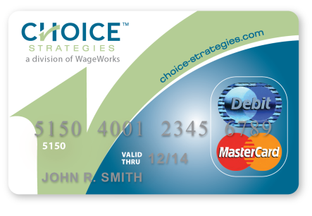
Effective: January 1, 2018
Plan Year: 1/1/2018 – 12/31/2018
Health benefits will be provided by Carrier, and supplemented by an Employer-funded Health Reimbursement Arrangement (HRA) with Choice Strategies, a division of WageWorks.

Health Reimbursement Arrangement – HRA
- Group Name is supplying you with a Choice Strategies HRA to pay for eligible medical expenses. Your account will be funded with:
  - $$$$ if you are participating as a single
  - $$$$ if you are participating as a two-person
  - $$$$ if you are participating as a family
- Eligible medical expenses include any expense that is applied to your Carrier deductible including, but not limited to:
  - Office Visits
  - Inpatient
  - Outpatient
  - Prescription (Rx)

Choice Strategies HRA Instructions
Medical Deductible Expenses
- When you visit a provider, present them with your Carrier Insurance Card. The provider bills Carrier first – do not present your Choice Strategies card at this time.
- Carrier then assigns the negotiated rates and applies charges toward your deductible.
- Carrier sends you an Explanation of Benefits (EOB) statement. Keep this for your personal records.
- When billed by the Provider, verify that it matches the EOB, and use your Choice Strategies card to pay the amount owed. Payments can usually be made by mail, phone or in person.
You will not need to submit the EOB to Choice Strategies, as we have partnered with Carrier to receive an electronic data feed, which we use to substantiate (verify) your transactions.
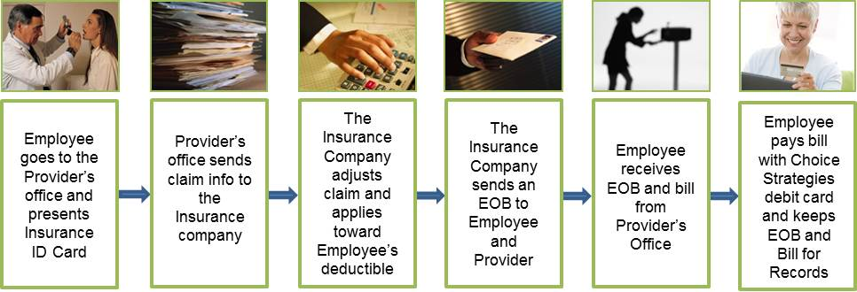

Prescription (Rx) Expenses
- Present your Carrier ID card to the pharmacist
- After your pharmacist processes the claim through Carrier, the pharmacist will ask you for payment at the time of service.
- Pay with your Choice Strategies card and the amount will be processed and applied toward your Carrier deductible (if applicable).
- It is a good idea to keep the detailed receipt – you may be contacted by Choice Strategies and asked to validate the purchase by providing documentation.
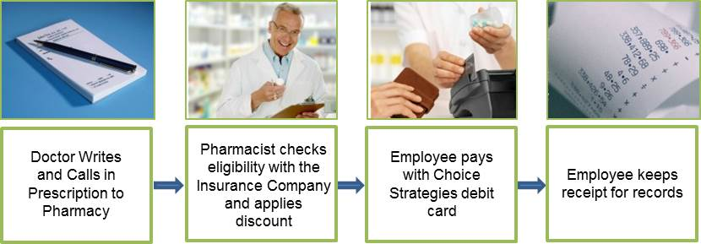

Flexible Spending Account – FSA (Optional)
- Group Name allows you to elect up to $2,650 to be contributed on a pre-tax basis via payroll deductions throughout the plan year into a Flexible Spending Account (FSA).
- FSA funds are best used to pay for predictable out-of-pocket expenses, because any funds contributed that are not used by the end of the plan year are forfeited under the IRS “Use it or Lose It” rule. REMOVE THIS PARAGRAPH IF CARRYOVER IS OFFERED
- FSA funds are best used to pay for predictable out-of-pocket expenses. If you do not use all of the funds in your FSA by the end of the plan year, up to $500 may be carried over into the next plan year. Any unused funds exceeding $500 will be forfeited due to IRS rules. REMOVE THIS PARAGRAPH IF CARRYOVER IS NOT OFFERED
- These funds can be used for all IRS-eligible expenses, including health plan deductible expenses, dental, vision and much more. An extensive list of eligible expenses is included on the next page, or visit: https://www.wageworks.com/employees/support-center/healthcare-fsa-eligible-expenses-table/

Dependent Care Account – DCA (Optional)
- Group Name allows you the option to contribute money on a pre-tax basis via payroll deductions throughout the plan year into a Dependent Care Account (DCA)
- The maximum contribution per household is $5,000 if you are single or if you are married and filing a joint tax return, or $2,500 if you are married, filing separate tax returns (per IRS guidelines).
- Eligible expenses include custodial care of dependents while employee is at work. For a more detailed search engine, see: https://www.wageworks.com/employees/support-center/dcfsa-eligible-expenses-table/

Examples of FSA-Eligible Expenses*

- Acupuncture
- Alcoholism Treatment
- Ambulance
- Artificial Limbs
- Artificial Teeth / Dentures
- Athletic Wrap / Brace
- Bandages
- Birth Control*
- Capital Expenses for Home Improvements Needed for Medical Care*
- Chiropractors
- Christian Science Practitioner’s Fees
- Contact Lenses and Solution
- Co-Payments
- Cost and Care of Guide Dogs
- Crutches / Canes / Walkers
- Deductibles
- Dental Fees (Non-Cosmetic)
- Diabetic Testing Supplies
- Diagnostic Fees
- Drug and Medical Supplies
- Eyeglasses – Prescription and OTC
- Eye Examination Fees
- Eye Surgery to Correct Vision
- Fertility Monitor and Treatment
- First Aid Kit
- Health Insurance Deductibles
- Hearing Aids, including Batteries
- Hospital Services Fees
- Insulin, Testing Materials and Supplies
- Lab Fees
- Lead-Based Paint Removal*
- Operations (for Non-Cosmetic Purposes)
- Medical Services Fees
- Organ Transplants
- Oral Surgery
- Orthodontic Fees
- Orthopedic Devices
- Over-the-Counter Medicines*
- Oxygen Equipment and Oxygen
- Part of Life-Care Fee paid to Retirement Home for Medical Care*
- Prescriptions
- Psychologist Fees
- Smoking Cessation Programs
- Special School or Home for Mentally or Physically Disabled Persons*
- Sunscreen (SPF 15 and higher only)
- Surgical Fees
- Transportation for needed Medical Care
- Treatment at a Drug or Alcohol Center
- Vasectomy
- Wages for Nursing Services
- Weight Loss Programs Associated with a Specific Disease*
- Wheelchair
- X-Rays

*Due to Healthcare Reform, some expenses and OTC medications, like aspirin or cold medication are eligible for FSA reimbursement only when accompanied by a prescription or letter of medical necessity from your provider. These expenses often must be reimbursed by claim submission instead of by using the Choice Strategies debit card.

For a more detailed search engine for FSA eligible expenses, see: https://www.wageworks.com/employees/support-center/healthcare-fsa-eligible-expenses-table/

Choice Strategies FSA and/or DCA Instructions
- Elect funds to be withheld on a pre-tax basis via payroll deduction for your FSA and/or DCA at Open Enrollment or when you become eligible for the benefit.
- FSA and DCA election amounts can only be changed once a year, during Open Enrollment, or in the case of limited qualifying events. To ensure that your election will be the best fit for your needs for the entire year, you can use the FSA tax calculator tool in the “For Members” section of our website www.choice-strategies.com as a guide when deciding how much to elect.
- Pay for eligible expenses with your Choice Strategies debit card and the amount will be deducted from your Choice Strategies account. For eligible expenses for which you cannot use your debit card, you can submit a claim for reimbursement (see below).
Keep the detailed receipt, as you may be asked to validate the purchase by Choice Strategies. FSA receipt documentation must include date of service or purchase, and itemized description of service or product. Credit card receipts are not considered sufficient documentation.
DCA documentation can be either a DCA claim form with the provider’s signature and Social Security # or Tax ID#, or a bill including the dates of the dependent care service, the dependent’s name and provider name.
- Your FSA is pre-funded by your employer, so although your FSA election will be deducted from your payroll evenly throughout the entire year, the full amount you elect for the entire year will be available for use on the first day of the plan year.
- DCAs are not pre-funded accounts, so funds for those accounts will become available as they are deducted from your paycheck each pay period - the entire annual amount is not available at once.
Because DCA funds accumulate over time, it is possible that you may incur expenses before funding is available to pay your entire claim. In this case, we will reimburse you for the current available balance in your DCA, and will place the remaining claim amount “on-hold”. The remaining on-hold claim amount will be automatically reimbursed to you as payroll contributions are transferred to your DCA.

Things to Remember with your Choice Strategies Account

- Choice Strategies Member Service help is available:
- 24/7: Members can access account balance, card status and order replacement debit cards 24/7 through our IVR (Interactive Voice Response) system.
- Phone: 1-888-278-2555 ext. 2 Mon-Fri 8am-8pm EST
    - Assistance is available in more than 200 languages
- Know all your benefits – it is important for you to understand the benefits you have with Carrier. If you have questions about your medical benefits, you may contact Carrier’s Customer Service at the number listed on the back of your Carrier ID card.
- Keep all your statements and Carrier Explanations of Benefits (EOBs) related to any Choice Strategies reimbursement. Your deductible transactions will be verified with the data feed, but there could be instances where you may be asked to provide additional documentation for some charges made with your Choice Strategies debit card.
- For any expense for which you cannot use your debit card, you can submit claims for reimbursement. For faster reimbursement, submit claims via your online account or mobile app. Paper claim forms are also available on our website, or if you do not have internet access, you can contact Member Services to have a claim form mailed to your home address.
You can submit your claim and documentation:
- Online: www.choice-strategies.com by logging into your online account
- Mobile App: claims can be submitted via mobile devices or tablets
- Fax: 1-888-415-6471
- Mail: Choice Strategies
P.O. Box 2205
South Burlington VT 05407

You can be reimbursed for submitted claims via:
- Direct Deposit / Electronic Fund Transfer (EFT) – your direct deposit information can be provided to Choice Strategies through your online account
- Check – made out and mailed to you
- Check – made out and mailed to your provider (this option available with online submission only)
- We encourage you to set up an individual online account, where you can access and manage a variety of information 24 hours a day, 7 days a week.
To set up your account, go to www.choice-strategies.com and click on the For Members tab. In the top right-hand corner of the page, click on Register, and follow the instructions. You will need the following information to set up your online account:
- Employee First and Last Name
- Social Security Number (referred to as Employee ID)
- Either your 16 digit Choice Strategies debit card number OR your Employer ID. The Employer ID is your company’s code starting with the letters “CHO”, which can be found on any letter you have received from Choice Strategies. You can also call Member Services to obtain.
Through your online account, you can:

- Check Account Balances
- Submit Claims Online
- View Transaction History
- Upload Documentation
- Change Direct Deposit Information

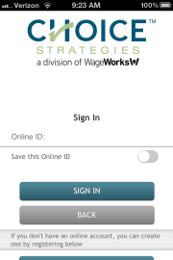
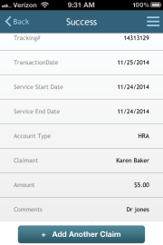
Mobile App
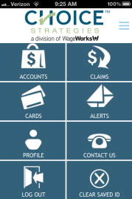
Available for iOS (Apple) and Android-enable mobile devices and tablets, the Choice Strategies app can be downloaded free of charge. Members can check account balances, view recent transactions, submit claims and upload a receipt or supporting documentation.

