
Time is running out to save on healthcare!
Open Enrollment ends on (date).
The last day to enroll in a Flexible Spending Account (FSA) is (date).

If any of these apply to you, an FSA can save you money:

- Have copays, deductibles or coinsurance for medical, dental or vision plans
- Purchase prescriptions
- Wear glasses or contacts or plan on having laser eye surgery
- Receive orthodontia treatments, such as braces
- Have children in daycare, before/after-school care or summer day camp
- Provide care for an older parent

Answer "YES" to any of these? Then an FSA can help you save money!

Enroll in an FSA during Open Enrollment.

For more information, visit www.SpendingAccounts.Info or call the FSA Hotline
at 1-800-228-5762.

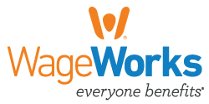
© 2017 WageWorks, Inc. ALL RIGHTS RESERVED.

