
Enroll in a Flexible Spending Account (FSA) and Save Money!
What is an FSA?

- An employee benefit that saves you money on eligible healthcare and daycare expenses.
- A way to SAVE MONEY and PAY LESS TAXES!

There are two types of FSAs:

- The Health Care FSA is used to pay for eligible out-pocket-medical expenses not paid by insurance (or other source) including copays, deductibles, prescriptions, glasses, braces, laser eye surgery and more!
- The Dependent Care FSA is used to pay for eligible child or elder care expenses, including daycare, before/after-school care and summer
day camp.

By using pre-tax money to pay for these expenses, you could save hundreds of dollars a year! (Your savings will depend on your personal tax situation.) Want to learn more and see how much you can save? Visit www.SpendingAccounts.Info or call the FSA Hotline at 1-800-228-5762.

Enroll in an FSA during Open Enrollment!
(insert dates)

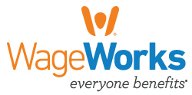
© 2017 WageWorks, Inc. ALL RIGHTS RESERVED.

