

FSA Member Transition Client Template – Initial Notice (Plans with Carryover)
The initial letter is intended for Clients to use to communicate information to current FSA members. Review the pre-populated dates for the various plan year start and end dates based on your company’s benefit plan year as needed. Include any additional benefit enrollment information pertinent for your company’s needs. Information in this letter specific to HealthEquity is not to be edited. Remove this top section in red prior to use.
Welcome to HealthEquity!
We have exciting news to share with you! As of the June 1, 2021, your Flexible Spending Account (FSA) will be administered on an enhanced HealthEquity proprietary platform! This communication informs you of important information about participating in these benefits.
See below for key dates and activity that may affect you during the transition period.
Important Transition Information
Current Plan Year Accounts  June 1, 2020 – May 31, 2021 | - You will continue to submit claims and receive reimbursements through the run-out period on the current system, if applicable. Visit myspendingaccount.wageworks.com to access your account. Your plan will remain on the My Spending Account platform for processing.  - If you have a Spending Account by WageWorks debit card, it will remain active through May 31, 2021.  - Your plan has a carryover feature that allows you to carryover unused funds as allowed by your employer to the next plan year. These carryover dollars will be added to your new HealthEquity account approximately 45 days after the prior year run out period ends if they have not been used by that point.  - You will have access to your account for 180-days after the run-out period has ended.
New Plan Year Accounts  June 1, 2021 – May 31, 2022 | - This is the first day of administration on the new platform for your FSA.  - If you have enrolled for a healthcare account for the new plan year, you will receive a new HealthEquity® Visa® Health Account Card¹ on or about the start of the new plan year.  - You can begin to access your FSA funds on the HealthEquity® Visa® Health Account Card¹ or submit for any out-of-pocket expenses you may have incurred since the beginning of the plan year.  - You can register and access your account at healthequity.com/wageworks. Select “Log In/Register” and then “Employee Registration” to create your unique HealthEquity credentials.  - Submit your claims using any of the following methods:  Online Claims or Pay My Provider  Log in and submit your claim at  healthequity.com/wageworks  EZ Receipts® Mobile App  Download the EZ Receipts® mobile app on your device  Fax or Mail (Paper Claim Form)  Access a Pay Me Back claim form at healthequity.com/wageworks

Frequently Asked Questions
General Account
How do I register my new account and view online program information?
Register your new online account by visiting healthequity.com/wageworks, selecting “Log In/Register” and then “Employee Registration” to create your new unique credentials. When asked for your ID Code in the self-identification process, use the last four digits of your Social Security Number. Complete your profile by:
- Entering your contact information
- Specifying your email and text notification preferences
- Identifying your preferred reimbursement method – check or direct deposit
- Updating your tax bracket to analyze cost savings
- Creating a username and password for ongoing access

How long will I have access to my current account?
You will have access to view your current account for 180-days after the end of the run-out and grace periods. Visit myspendingaccount.wageworks.com to access your account.

Will my direct deposit details transfer to my new account?
If you opted for direct deposit for reimbursements from your My Spending Account account(s), you will need to sign up for direct deposit on your new account at healthequity.com/wageworks. Please login to your account and update your reimbursement method in your profile. Please allow up to two weeks for confirmation of your account numbers with your financial institution. Any claims submitted during this time will be reimbursed via check.
Will my carryover funds be available on my new plan year account?
Carryover dollars remaining on your My Spending Account will be added to your new HealthEquity account approximately 45 days after the prior year run-out period ends if they have not yet been used by that point. All prior plan year claims must be directed to the My Spending Account platform during the regular run out period.

I did not enroll in an FSA for the new year, but I will have a carryover amount. How will I know when my carryover money is posted to the new system?
If you did not elect an FSA for the new year, your carryover funds will appear as an account adjustment and an FSA will be created for you. Your funds will be added to the new account approximately 45 days after the prior year run-out period ends.
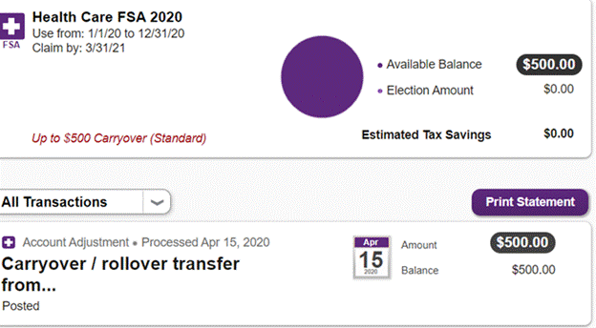

I elected an FSA for the new year, will my carryover funds be added into a separate plan as they did before?
The carryover plan will no longer be reflected as a separate plan. If you enrolled in an FSA for the new year, your carryover funds will appear as an account adjustment and will be added to your current years account balance.
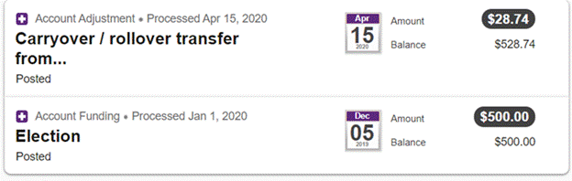

Where can I find additional resources and information about my new FSA?
Visit healthequity.com/wageworks and select ‘EMPLOYEES’ and then ‘Support FAQs’ to learn more about the plans.
Debit Cards
Will I receive a new debit card?
Yes, if you have enrolled for a healthcare account for the new plan year, you will receive a HealthEquity® Visa® Health Account Card¹ on or about the start of the new plan year.
The card will be mailed to your home address on file with HealthEquity. Additional cards for spouses and/or dependents may be requested through the Participant Site ‘Card Center’ tab.

Will my current Spending Account Card by WageWorks debit card still work?
If you have a Spending Account by WageWorks debit card, the FSA balance will remain active through May 31, 2021.
Claims
How do I file a claim on my new account?
Effective as of the new plan year, you will be able to access your new account online to request reimbursement for your eligible expenses. You can also use the EZ Receipts® mobile app to submit claims from your mobile device. If you would like to fax or mail your reimbursement request, please visit healthequity.com/wageworks and select “Employees” from the top toolbar and then “Important Forms” from the “Support Center” list.

With the EZ Receipts® mobile app, you can file and manage your reimbursement claims and card validation paperwork on the spot. To access your online account on the go with the EZ Receipts® mobile app, visit healthequity.com/wageworks and select “Log In/Register” and then “Employee Registration” to create your unique account credentials.

How do I file a claim on my current account?
You will continue to submit claims and receive reimbursements through your run-out period using the current methods. Visit myspendingaccount.wageworks.com to access your account and submit a claim. We urge you to try and submit these incurred expenses as soon as possible to help reduce your current account balance.

What if I had a Letter of Medical Necessity (LMN) set up with My Spending Account?
- Non-chronic conditions – A LMN is required for any service or product that falls under the category of “Potentially Eligible Expense” or “Ineligible Expense” per IRC Sec. 213 (d). If a LMN has not been provided or was provided prior to January 1, 2020, you will need to provide a new LMN to HealthEquity/WageWorks with your first claim. For more information, please visit healthequity.com/wageworks and select “Employees” from the top toolbar then “Important Forms” from the “Support Center” list.
- Chronic conditions – A LMN for chronic conditions will automatically transfer without regard to the date your letter was received by HealthEquity/WageWorks.

1. The Card can be used at participating merchants who sell eligible healthcare products or services everywhere Visa debit cards are accepted. Your HealthEquity Visa Healthcare Card is issued by The Bancorp Bank pursuant to a license from Visa U.S.A. Inc. The Bancorp Bank; Member FDIC.

